1. Construct your business model, using business model canvas model

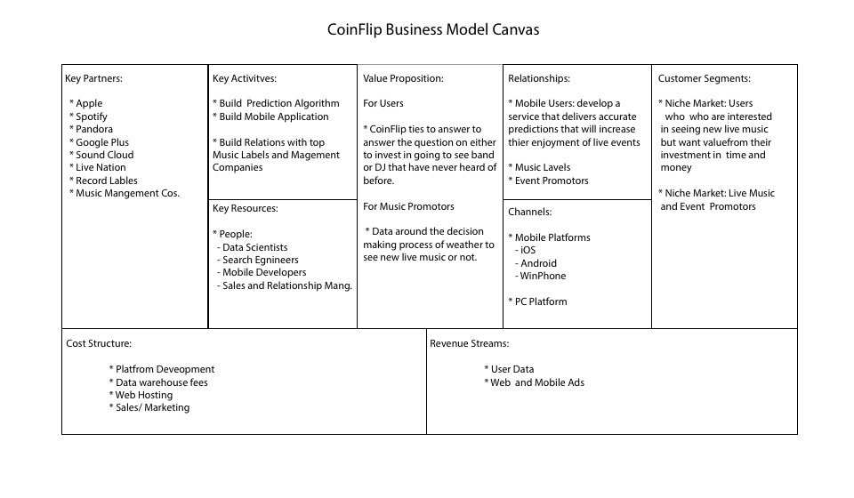

2. Analyze the market your product is in, using Porter's five forces

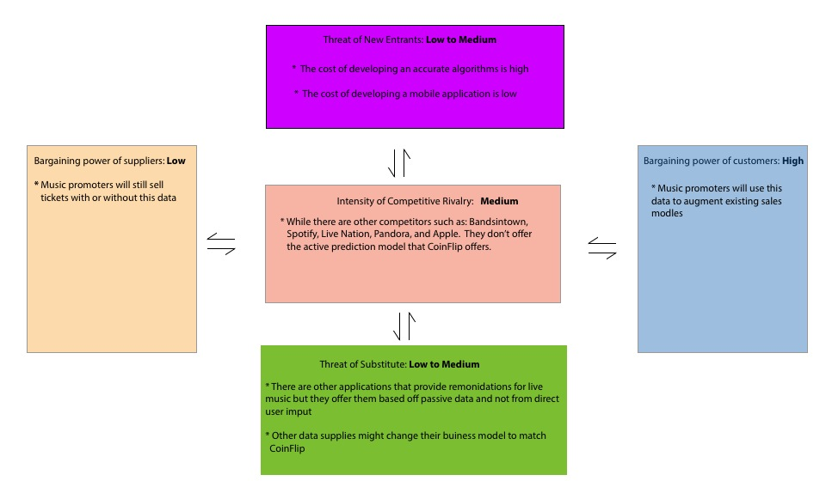

1. Size-up the market for your product.

Target Demographic: Adults 18-44: **112,806,642**

Percentage of Adults who have mobile phones: **91**

Target Demographic with cell phones: 112,806,642 x .91 = 102,654,044

Parentage of Mobile Phone users with Applications: **43**

Target Demographic with mobile phones and applications: 102,654,044 x .43 = **44,141,239**

Percentage of population who attend live cultural events: **40**

Market Size for CoinFlip: 44,141,239 x .40 = **17,656,495 users**

**4. Market Trends effecting CoinFlip**:

**Live Music** The decline of revenue from music purchases (physical and digital music) as not extended to Live music. Advances in technology and data science are reshaping how events are planned, experienced and managed. The live music market is still expanding. The live event and promotion service Live Nation posted over a billion dollar revenue increased between the years from 2011 to 2013.

**Mobile:** Mobile is quickly becoming the preferred development platform. Over a 102 million Americans between the ages of 18-44 own a cell phones. Users are spending more and more money on this platform, Apple alone generated 10 billion dollars in mobile purchases in 2013.

**Data Science**: Businesses are trying to make sense of more than “250 billion…likes,” and social data; furthermore, they are trying to untangle over 2 billion bits of “data points” each day, notes research conducted by 140 Proof. Using data to tell a story of costumer behavior is becoming more of business necessity. Companies are willing to pay for data about how users are spending their money.